Southern Tier Chapter of
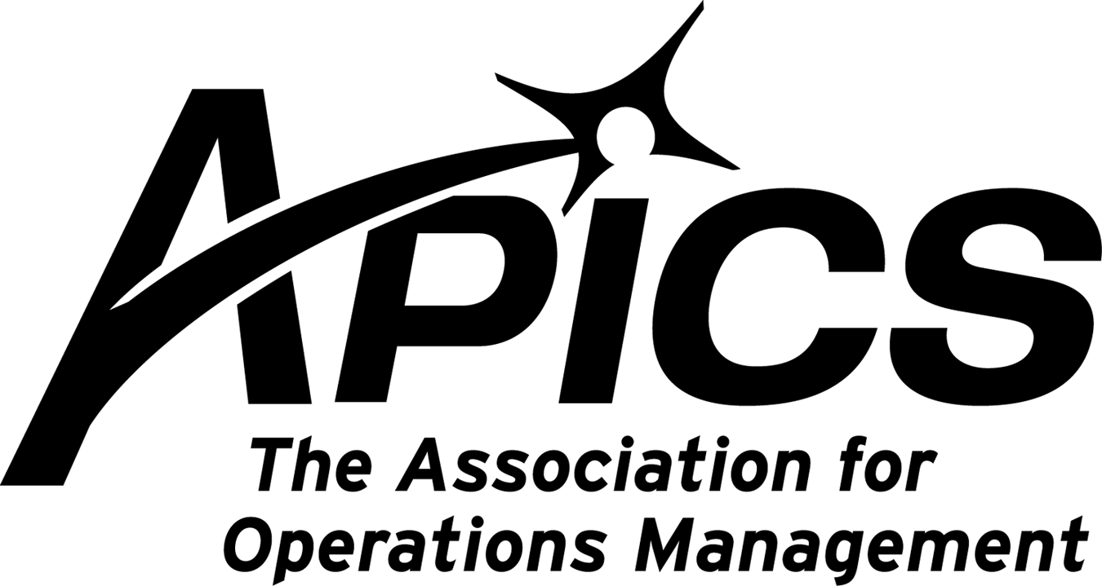
www.stapics.org

“Advancing productivity and innovation and competitive success.”

APICS & NAPM DINNER MEETING

Thursday, October 20

Location: Grande’s Restaurant
1250 Upper Front Street, Binghamton

Guest Speaker:
Jason D. Tripp
Retirement Planning Specialist
AXA Advisors, LLC

5:30PM Sign-in and Networking
6:00PM Dinner
6:30PM Guest Speaker

Dinner: Order off Menu

Cost: Members $15. Non-members $20.
Excludes drinks

RSVP by 10/17/11 to Keith_Jamba@uhs.org or by calling 607-763-5138

Thanks and hope to see you there!

The Southern Tier chapter once again wins Silver award for C-BAR!

Your Southern Tier chapter has once again been awarded the Silver award level for C-BAR! That’s now 4 years in a row!

C-BAR? What silly acronym is that?

C-BAR stands for Chapter Benchmarking and Reporting Program. It’s APICS’ way of assuring that each local chapter meets APICS minimum standards. The chapters are measured against a set of standard criteria. Those who excel – such as our chapter – win awards. Think of it as APICS’ form of quality control; it ensures that the Board of Directors promotes local educational opportunities and does not take a vacation to Aruba with your membership dollars.

As APICS’ corporate headquarters puts it,

Chapter Management Excellence is an integral component to enhancing the member experience. Successful APICS chapters provide their members with opportunities for stellar education, career development, and networking.

The APICS Chapter Benchmarking and Recognition (C-BAR) program recognizes chapters that have exceeded minimum standards and exemplify excellence in overall chapter management. We are proud to announce the APICS Southern Tier Chapter received the 2010 C-BAR Silver Award designation, an admirable accomplishment for an APICS chapter.

As a member of an APICS Silver Award Winning Chapter, the C-BAR designation signifies your chapter’s commitment to providing an exceptional membership service.

Award levels are Bronze, Silver, and Gold. If you have any questions about the C-BAR program, please contact Lee Schechter at lschechter@stny.rr.com.

APICS News from Don Sheldon, Vice President of Education

Re-Certification – Time is running out for those of you who have let their certification lapse. December is the last chance to get re-certified without having to take all the exams again. The Southern Tier APICS Chapter is proposing a study group led by a Master Trainer (Either Dave Gardner or me) to do readiness training for the recertification exam. It will be scheduled once we have a roster of interested students. We are entertaining 4 afternoons (16 hours total-probably 2-6pm each session) to review materials from study notes. We will also do practice questions similar to what might be on the exam.

The Cost will be $250 plus the book cost. We will use the 2010 APICS CPIM Exam Content Manual which can be downloaded with qualification approval by APICS for free (see http://www.apics.org/Certification/RecertificationExam.htm) and Brian Willcox Study Notes series also from APICS ($147).

If you are interested in this study class, please contact me at dsheldon@sheldoninc.com. If we get enough to sign up, we will run it. Thanks!

CSCP Training – I know CSCP has also been a moving target and I apologize but between the lack of student interest and my busy schedule, this keeps moving out in the schedule. It is still the intention of the Southern Tier Chapter to offer CSCP in 2011. BCC is planning to help sponsor this but the grant has not been finalized. Keep in touch to get the latest on this schedule.

If you are interested in any of the Southern Tier offerings, please contact me at dsheldon@sheldoninc.com. Thanks!

APICS Conference, Pittsburg – It is rare when an APICS International Conference is a “driver” from the Binghamton area. It is this year and you should take advantage of this opportunity. Join me for the 2011 APICS International Conference & Expo APICS 2011 educational sessions will explore emerging strategies and real-world applications for sustainable productivity, as shared by industry leaders in risk and change management, supply chain strategy, sustainability, and more. Register now to gain valuable expertise in driving productivity, meeting consumer demand, and remaining agile amid instability and unpredictability.
2011 APICS International Conference & Expo
October 23–25, 2011
David L. Lawrence Convention Center
Pittsburgh, Pennsylvania, USA
Register now.

We’re on !!!
Come and visit, poke around, or comment on us! Our name there is “Southern Tier APICS”. It’s just another way
for us to keep in touch with our membership.

For the latest in chapter happenings check out WWW.STAPICS.ORG



Your 2011-2012 Board of Directors

President / VP Education Dave Gardner dgardner@akraturn.com
VP Membership / Website Lee Schechter lschechter@stny.rr.com
Executive VP / Director of Finance Steve Whited steve.whited@mwv.com
Director of Education Don Sheldon dsheldon@stny.rr.com
Publicity / Marketing / Programming Michael LoSapio Michael.losapio@synergyresources.net
Marketing Director Kelly Norieka Kelly.norieka@lmco.com
Secretary Deb Unkel deb.unkel@raymondcorp.com
Director at Large Steve Stanchak steve.stanchak@infoprint.com
Director at Large Brian Arnold barnold@amphenol-aao.com

Southern Tier APICS
PO Box 1107
Binghamton NY 13902-1107

